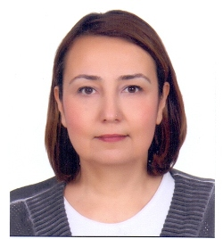

Doç. Dr. Yelda CANDAN DÖNMEZ

Ege University Faculty of Nursing
Department of Surgical Nursing
35100 Bornova Izmir
Tel: 0090232 3881103-5566
GSM: 0090 5065827053
Fax: 0090232 3886374

She graduated from Ege University School of Nursing in 1993. She completed her master's degree in 2000 and her doctorate in 2006 at Ege University Health Sciences Institute, Department of Surgical Nursing. Between 1998-2006, he worked as a research assistant at Ege University Faculty of Nursing, Department of Surgical Diseases Nursing, between 2006-2007, he worked as a lecturer at Ege University Odemis School of Health, between 2007-2012 he worked as an assistant professor at the same institution, between 2012-2018. She worked as an assistant professor at Ege University Faculty of Nursing and as a faculty member between 2018-2020. In 2020, she received the title of associate professor of Surgical Nursing. He carried out administrative duties as Deputy Director and Board Member of Ege University Odemis School of Health and Member of the Faculty Board of Ege University Faculty of Nursing. She served as a member of the Board of Directors of the Turkish Surgical and Operating Room Nurses Association. She is a founding member of the Association to Fight Breast Cancer. She currently serves as Deputy Director of Ege University Institute of Health Sciences and Responsible Manager of Ege University Faculty of Nursing First Aid Training Center.

